**Qno.1)**

→ **Objective:** To perform operations such as +, -, *, /, **, //, mod

→ **Task name:** Write a program in GNU prolog to perform operations such as +, -, *, /, **, //, mod

→ **Code:**

calc :- X is 100 + 200,write(X),nl,

Y is 400 - 150,write(Y),nl,

Z is 10 * 300,write(Z),nl,

A is 100 / 30,write(A),nl,

B is 100 // 30,write(B),nl,

C is 100 ** 2,write(C),nl,

D is 100 mod 30,write(D),nl.

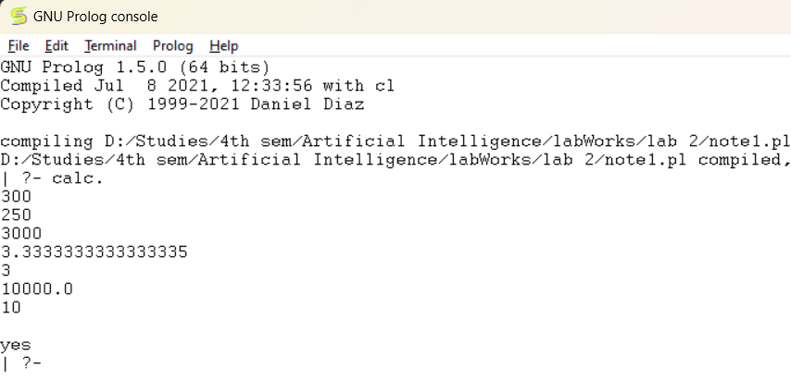→ **Output:**

**Qno.2)**

→ **Objective:** To represent facts in GNU prolog

→ **Task name:** Represent given statements as facts in prolog

→ **Code:**

gt(X, Y) :-

X > Y,

write('X is greater than Y').

gt(X, Y) :-

X =< Y,

write('Y is greater than or equal to X, This is if-else statement').

gte(X, Y) :-

X > Y,

write('X is greater than Y').

gte(X, Y) :-

X =:= Y,

write('X and Y are the same').

gte(X, Y) :-

X < Y,

write('X is smaller than Y, This is if-elif-else').

lt(X, Y) :-

X < Y,

write('X is less than Y').

lt(X, Y) :-

X >= Y,

write('Y is less than or equal to X, This is if-else statement').

lte(X, Y) :-

X < Y,

write('X is less than Y').

lte(X, Y) :-

X =:= Y,

write('X and Y are the same').

lte(X, Y) :-

X > Y,

write('X is greater than Y, This is if-elif-else').

eq(X, Y) :-

X =:= Y,

write('X and Y are equal').

eq(X, Y) :-

X =\= Y,

write('X and Y are not equal, This is if-else statement').

neq(X, Y) :-

X =\= Y,

write('X and Y are not equal').

neq(X, Y) :-

X =:= Y,

write('X and Y are equal, This is if-else statement').

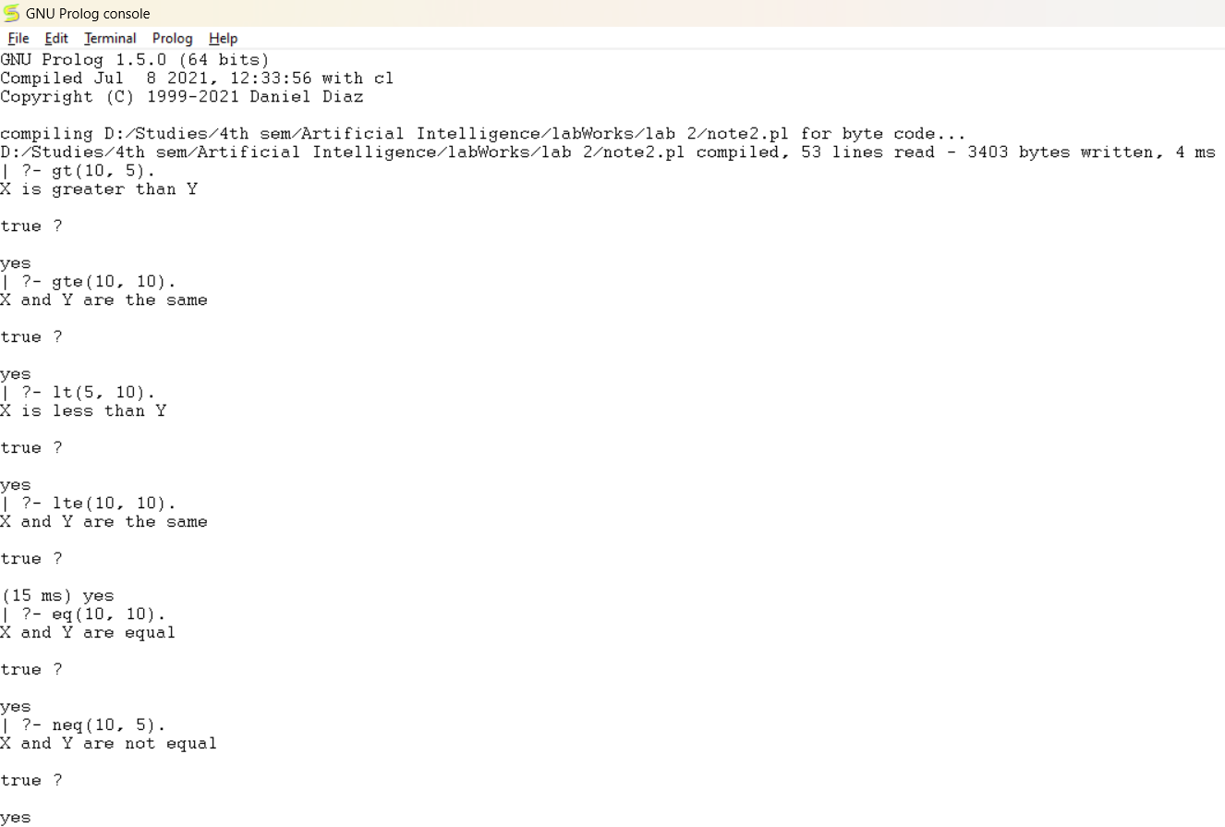→ **Output :**